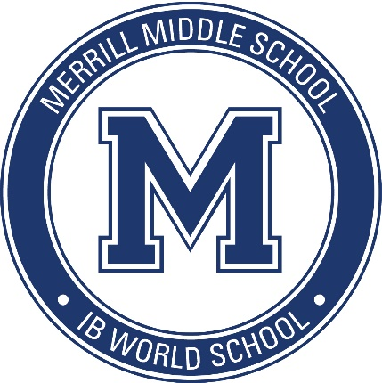
Merrill Middle School Academic Honesty Policy
2015 - 16
Last Updated: March 2016

This document is meant to be used in conjunction with Merrill’s Assessment Policy, Inclusion Policy, and Language Policy.
The IB Middle Years Programme
The IB Middle Years Programme (MYP) is constructivist in its approach, meaning that learning is a contextualized experience for students. Part of the constructivist nature of the MYP requires that students discover meaning and come to understandings through inquiry, the contexts for learning, and research.
Purpose of Policy
The purpose of this policy is to:
- Clearly articulate the definition of academic honesty and support application of standards set forth in this document
- Explain the roles of administrators, teachers, staff, students, and parents in creating an environment of academic honesty
- Help students understand the importance of academic integrity
Philosophy
The Merrill Middle School community values academic honesty and believes that it is critical for students to understand its importance. Through participation in the MYP, we desire that all students learn the values and skills necessary to be lifelong learners, while being principled in their approach.
Development and dissemination

The Academic Honesty Policy was developed in conjunction with parents, students, community members, faculty, and staff. It will be reviewed annually by stakeholders. The policy is posted at www.merrill.dmschools.org, made available in hard copy form and provided to all Merrill community members as requested.

Definitions and Examples
Academic Honesty
Students who exhibit academic honesty are principled in their academic work. Integrity, honesty, and fairness are integral components of this trait, and students take responsibilities for their actions and the consequences of their actions.

Academic Misconduct
IB defines academic misconduct as “behavior that results in, or may result in, the student or any other student gaining an unfair advantage in one or more assessment component.”
Plagiarism

Plagiarism is the act of representing someone else’s ideas or words as your own. Some examples of plagiarism are:
- Absence of a bibliography or works-cited page
- Copying directly from a text without proper citations
- Paraphrasing information from a text without attributing the source

Cheating

Examples of cheating include:
- Sabotaging (deliberately destroying) another person’s academic work
- Participating in collusion
  - Gaining information from one or more peers
  - Copying another student’s work
  - Looking at someone else’s paper
  - Submitting someone else’s work
  - Allowing a peer to copy
  - Doing homework for another student
- Using unauthorized notes on a quiz or test
- Communicating with other students during a quiz or test, including verbal, non-verbal, and technological communications
- Using electronic devices or computer programs to gain unfair advantage
- Engaging in unauthorized use of a language translator in Language Acquisition classes
- Presenting the same work in different courses without teacher permission

Consequences
Under Des Moines Public School policy, any student who engages in academic dishonesty will incur a Level One Act of Misconduct. At the discretion of Merrill administration and faculty, classroom consequences may also occur. Please refer to the Parent Handbook for more information.

Roles within Merrill’s Academic Community

Administrators’ Role:
- Lead the staff in a principled approach to instruction as the instructional leaders of the building
- Model academic honesty
- Support the faculty in upholding the academic standards of the programme
- Understand the role that academic honesty must play in the MYP
- Make decisions about a breach in academic policy
- Communicate the importance of academic honesty to all stakeholders
Teachers’/Staff’s Role:
- Lead the students in a principled approach to learning
- Model academic honesty
- Uphold guidelines where there is a breach in academic standards
- Teach the Modern Language Association (MLA) referencing system
- Help students understand the credibility of sources, including websites
- Teach students to properly attribute sources of information
Students’ Role:
- Approach learning in a principled way
- Abide by Merrill’s Academic Honesty Policy
- Recognize what constitutes cheating and plagiarism
- Utilize technology in a principled manner
- Diligently track the use of resources
- Attribute sources of information through the use of parenthetical documentation, bibliographies, or works-cited pages
- Properly quote and paraphrase information from sources
- Acknowledge any academic support they receive
Parents’/Guardians’ Role:
- Support students in their work and encourage them to take a principled approach to academics
- Understand the role that academic honesty must play in the IB Middle Years Programme
- Realize that the academic support they give their students must still allow the students to do the work themselves
- Recognize what constitutes cheating and plagiarism

Sources:
Carroll, Jude. "Academic Honesty in the IB." Cardiff: International Baccalaureate Organization,

2012. Print.

MYP: From Principles into Practice. Cardiff: International Baccalaureate Organization, 2014.

Print.

